**Firmware Upgrade Utility**

Table of contents

1. Objective 3

2. Prerequisites 4

3. Procedure 5

1. Objective

This document describes how to use PC utility for upgrading ZB-MODBUS firmware.

1. Prerequisites

The following H/W and S/W are required to setup boards and flash relevant firmware.

* Windows 10 PC   
  The firmware upgrade utility is built for Windows so a Windows 10 based PC is required.
* USB RS485 adapter

Since ZB-MODBUS interface only supports RS485 interface, a RS485 USB adapter is required to upgrade ZB-MODBUS firmware

1. Procedure
2. Attach RS485 USB adapter to PC and connect the adapter with ZB-MODBUS board using RS485 cable.
3. Execute Modbus Firmware Downloader PC Program. The following screen will pop up.

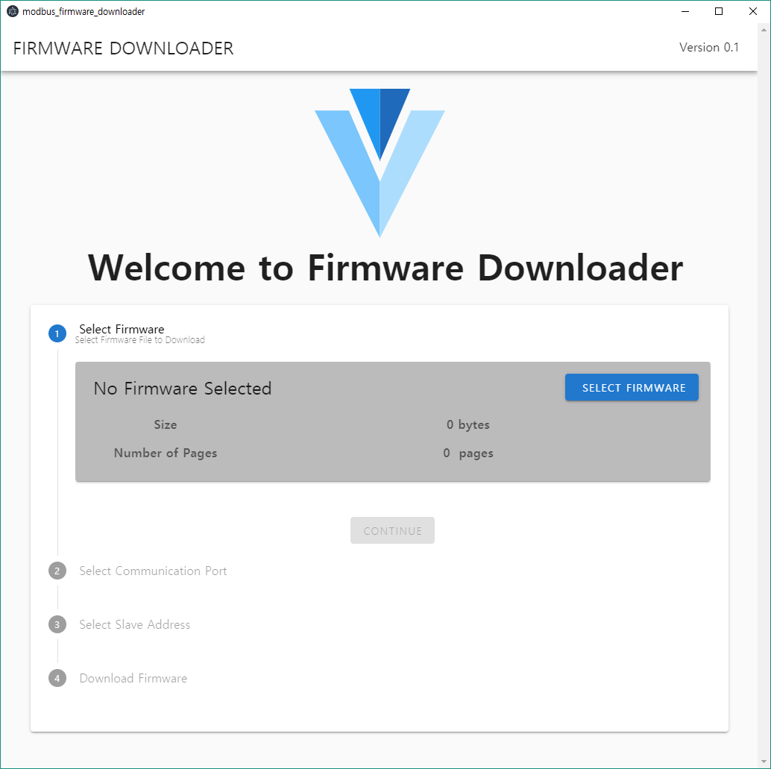

1. Select Firmware

For ZB-ANA/485, Select ANZB-1281-MODBUS-vXXXX.hex file  
For ZB-HART, Select ANZB-HART-MODBUS-vXXXX.hex file



1. Click

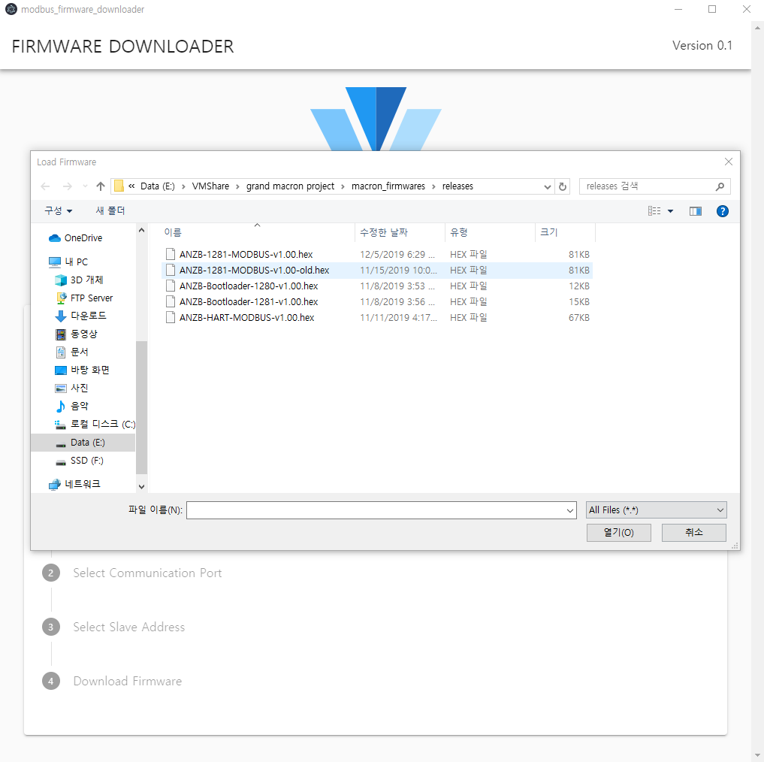

1. Select Firmware hex file

Click Continue After File Selection

1. Select Comm Port

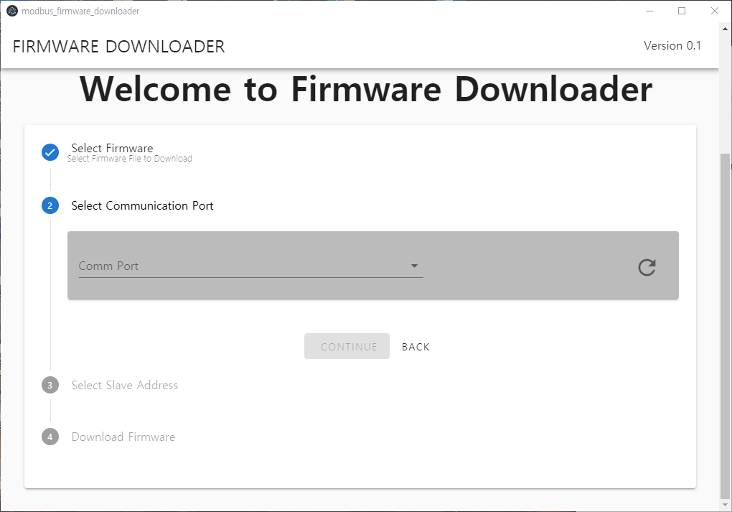

2. Click Continue

Refresh Port List if necessary

1. Select Comm Port
2. Select MODBUS Slave Address

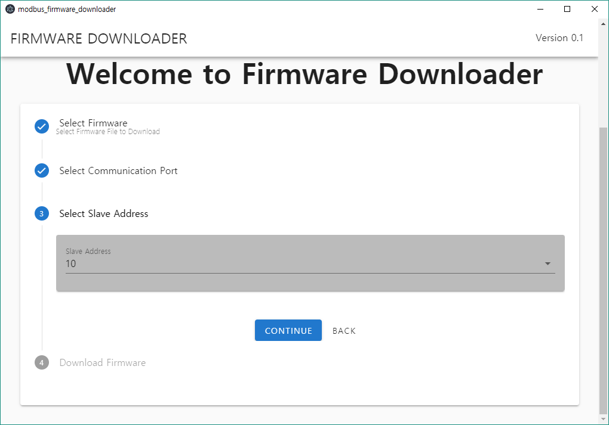

1. Click Continue
2. Select Address
3. Review Selections and Press Download

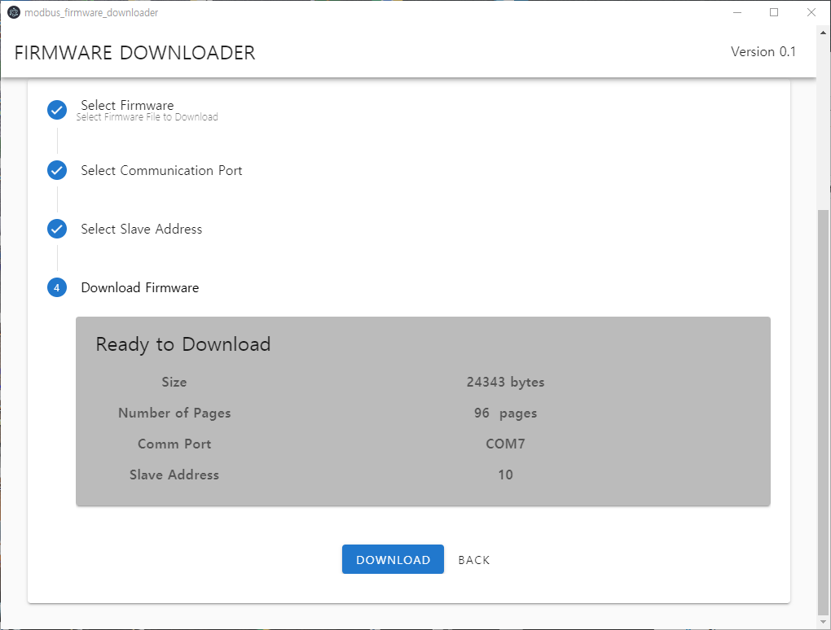

1. Click Download
2. Review Selections
3. Monitor Download Progress

